**Name: Arma**

**RolSl no:**

**Graded Lab: 3**

**________________________________________________________**

**Q: 1**

select customerName

from customers as c

where exists(

select *

from orders as o

where c.customerNumber= o.customerNumber

and year(shippedDate)=2005

);

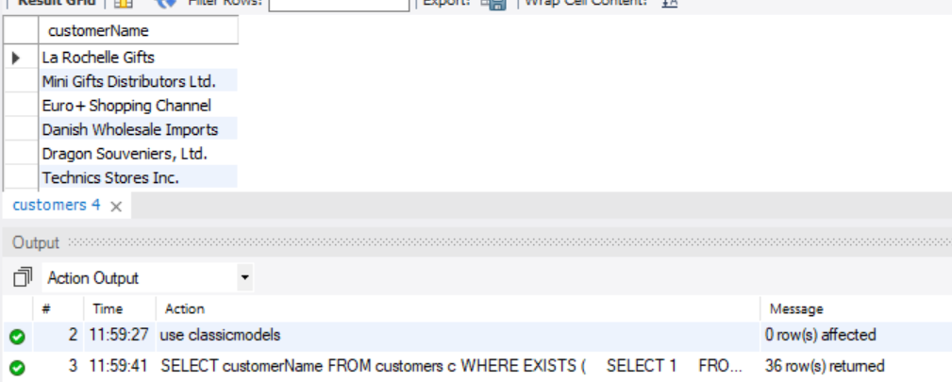

**Q: 2**

select c.customerName

from customers as c

where "On Hold" = any (

Select status

from orders as o

where c.customerNumber=o.customerNumber

);

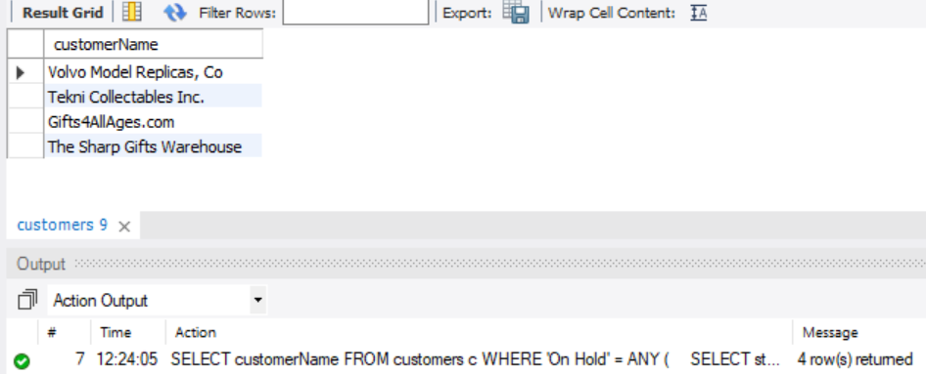

**Q: 3**

Select c.customerName , count(orderNumber)

from customers as c

left join orders as o

on c.customerNumber = o.customerNumber

group by c.customerName;



**Q: 4**

select p.productName, sum(quantityOrdered)

From products as p

Join orderDetails as o

On p.productCode=o.productCode

Group by productName;

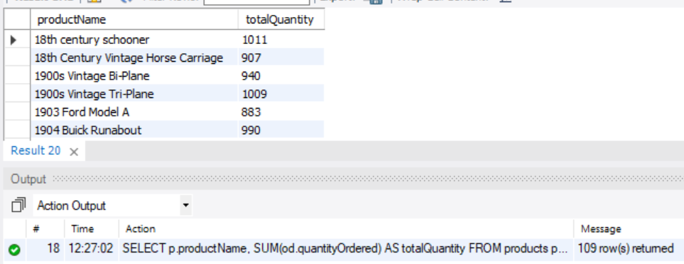

**Q: 5**

Select customerName

From customers as c

join payments as p

on c.customerNumber = p.customerNumber

group by customerName

order by sum(p.amount)

limit 1;

